Date: MAY 28 2021 File: C:\Karapetyan\18501 Нержавейка на ПКС - в расчет\03_program\4\18501 Нержавейка 4001.NST

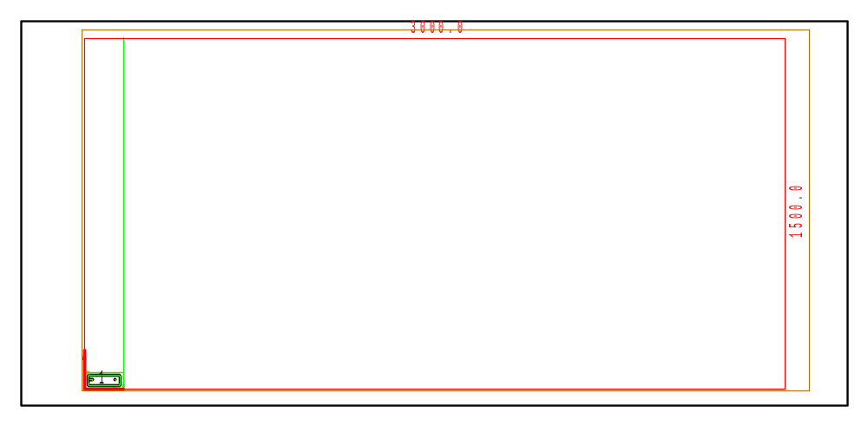

PART INFO
NC File Name: Ê!Å;Ä2RÅ1ÌÌ4001vËÍ
Draft no.: | Version:
Order no.: | Description:
SHEET Number of sheets: 1
Material: Stainless | Sheet size: 3000 X 1500 | T= 4.0
No. of parts: 1 | Part size:
Part weight: | Sheet weight: 140.40 kg
MACHINE:
MODEL: ML3015EX |  | Con. name: SUS304 |  | Table name: ML45CF_R_EX
Gas: N2H | Lens: 7.5 Inches |  | Nozzle diameter: 2.5
Speed: 3000 |  | Used laser power: 4500 |  | Beam diameter (kerf): 0.32
PROGRAM
Number: 4164 | File size: 2415 | Programmer:
Notes:
JOB TIME (min:sec)
Travel: 00:03 | Cut: 00:45 | Pierce: 00:17
Travel way: 937.6 mm | Cutting way: 0 mm | Pierce Qty.: 7
Total time: 01:04

 | Part name | DX | DY | QTY
1 | Ê#Å;32.70.04.01.094ÌÌÌ_Ì_2WËÍ | 140 | 45 | 1

